PROGRAM REASONING

ASSIGNMENT - 7
S.Abhishek
AM.EN.U4CSE19147
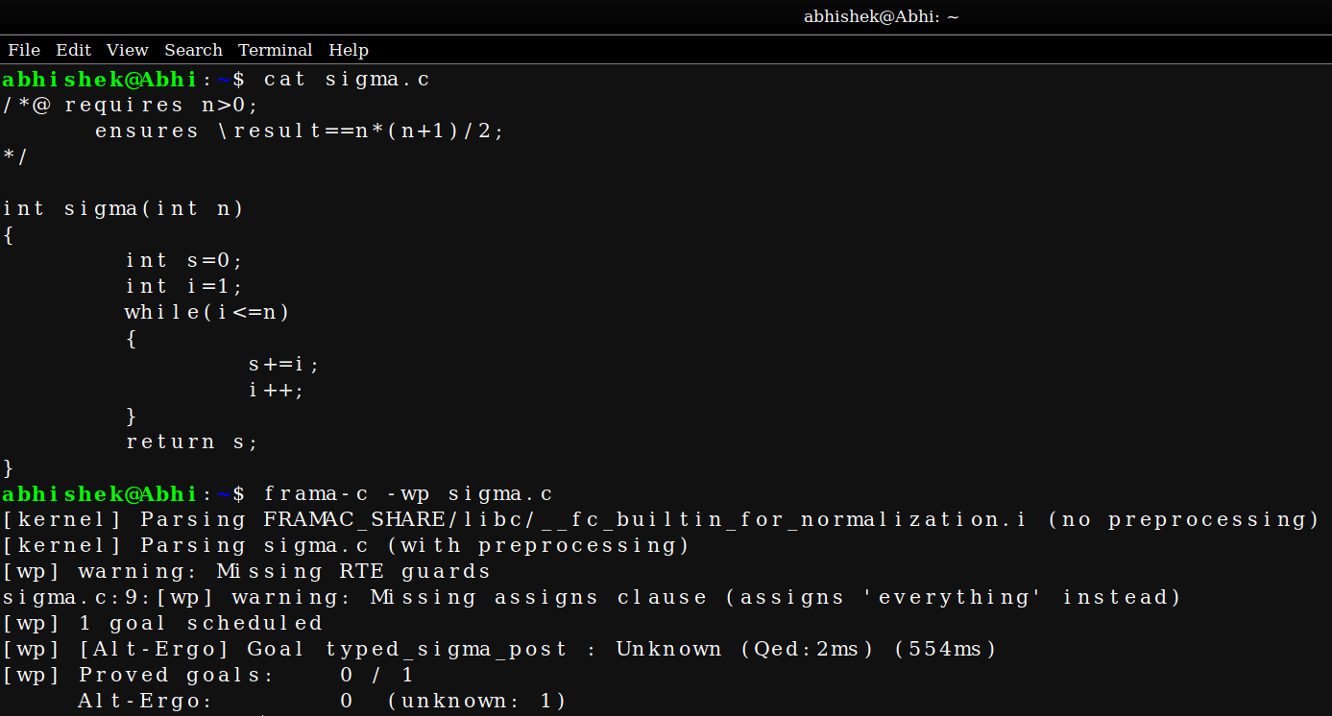

Here since its loop the specification which we gave is not strict and we need to give specifications for Iterations also.
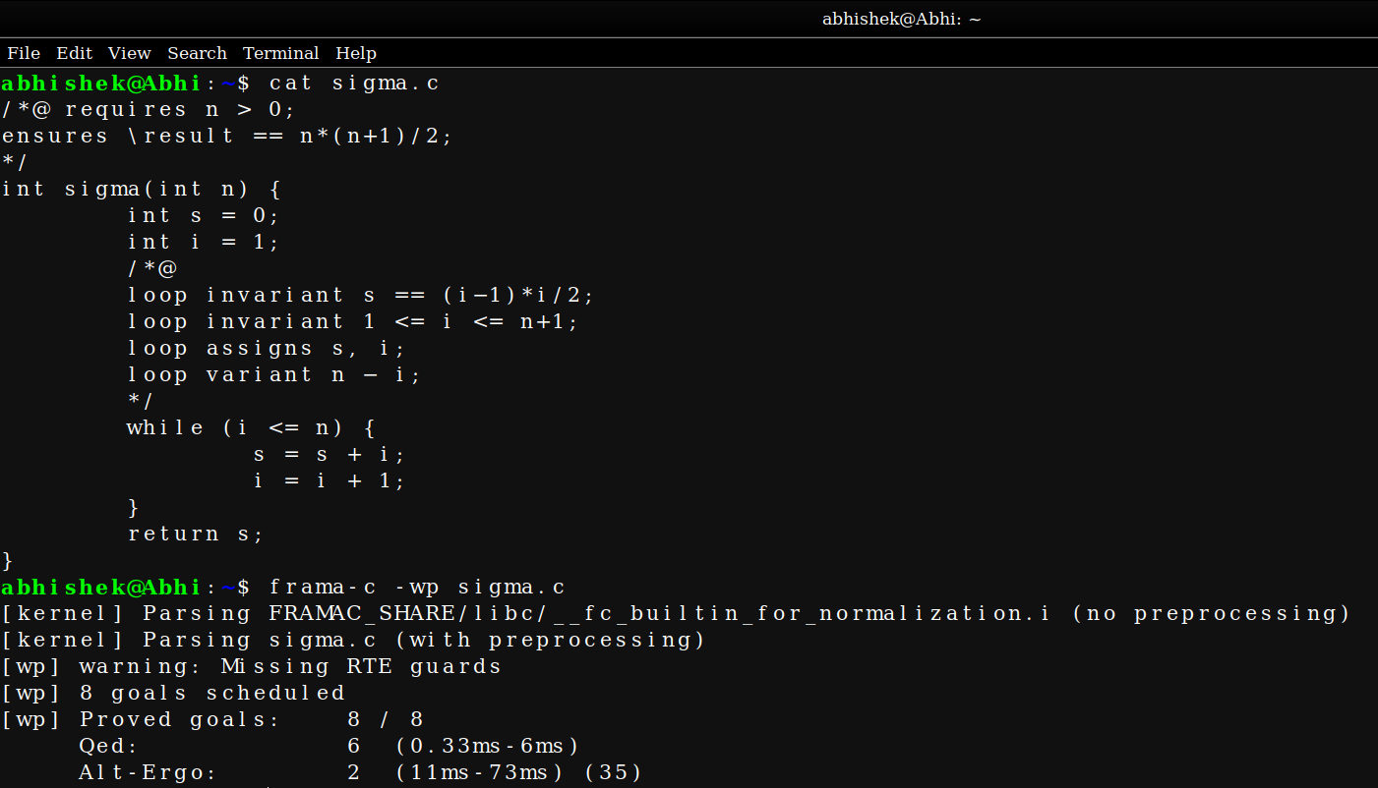

Now after giving specifications its proved.

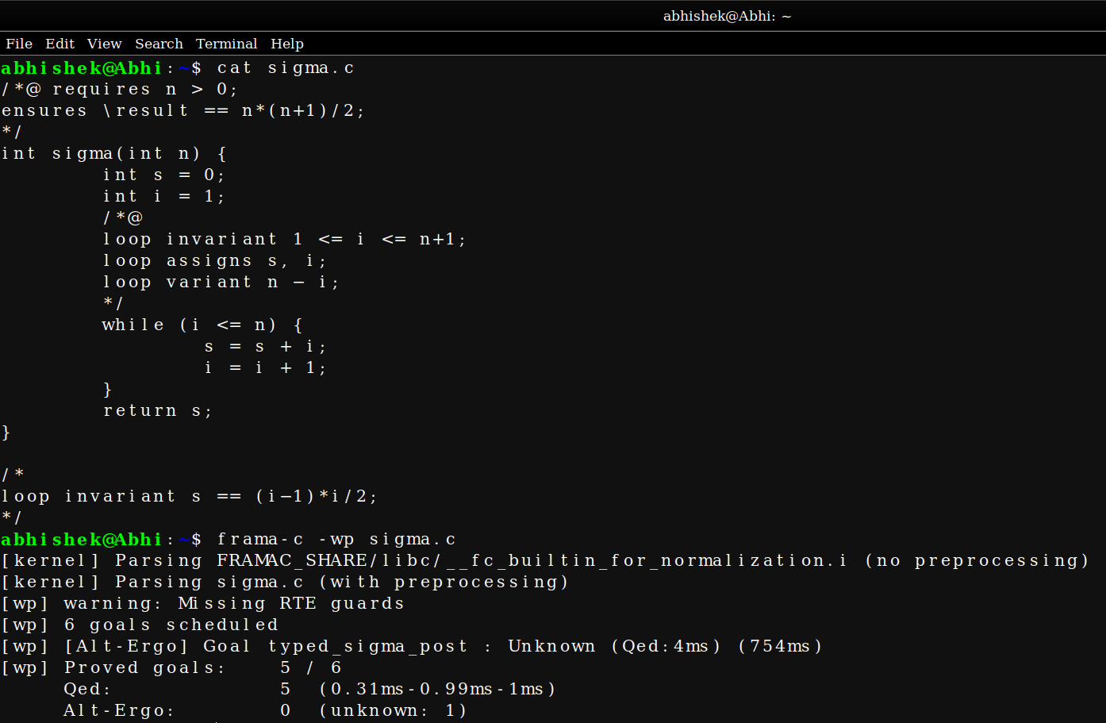

Here we removed the specification which checks the correctness of the sum thats being computed after each iteration and hence it gives errors since it cant prove the sum values after each iterations.

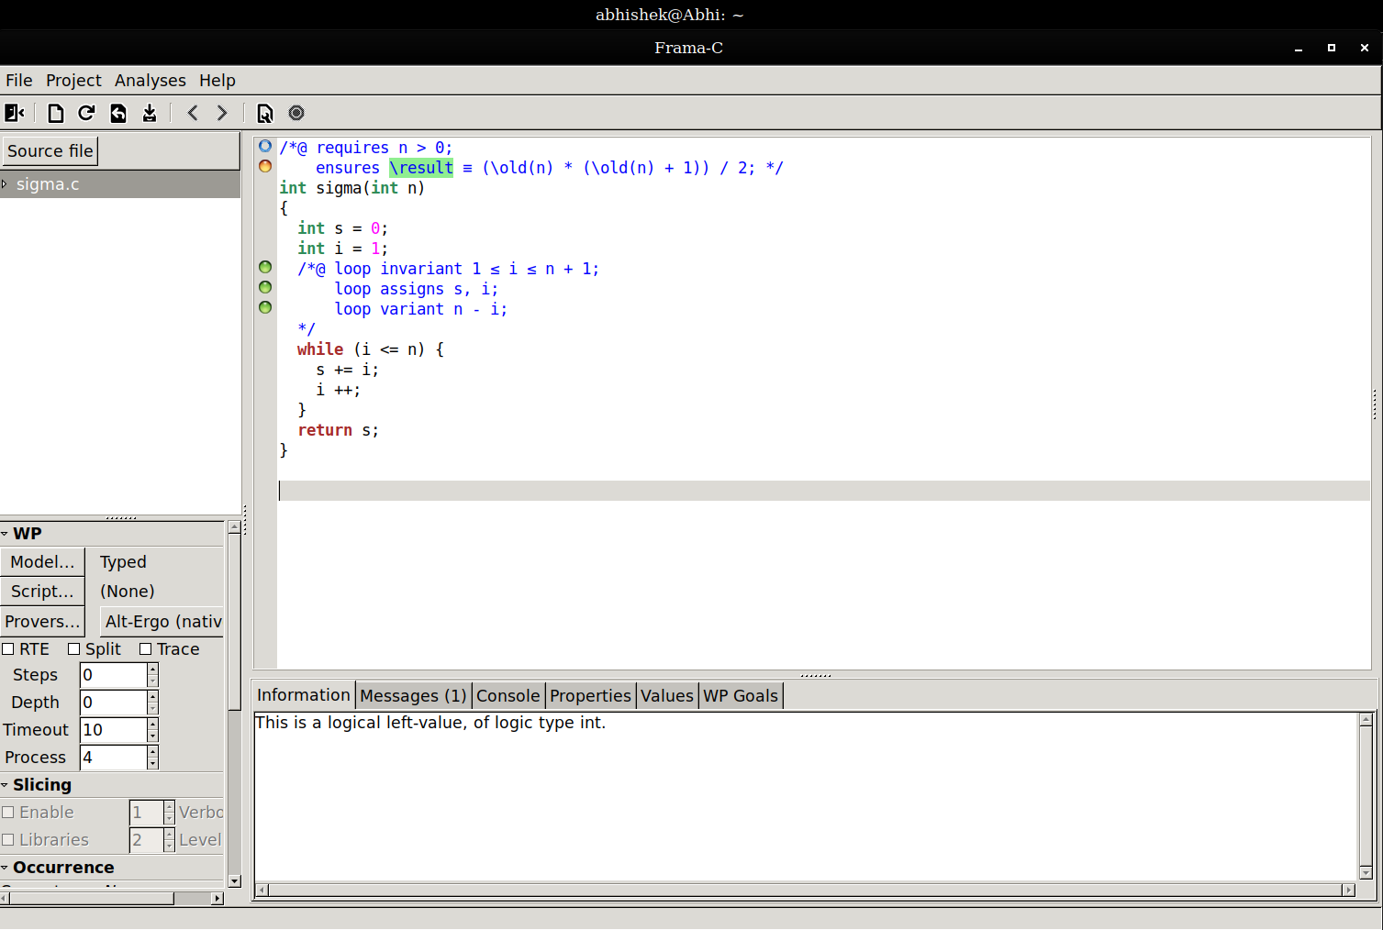

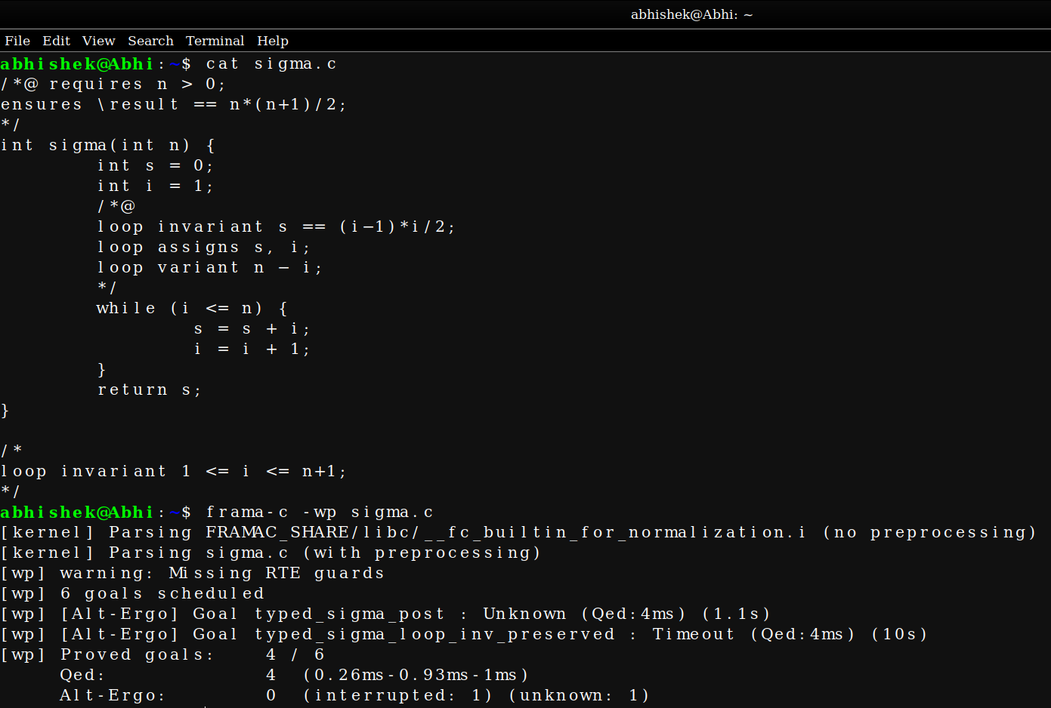

Here we removed the iteration conditon.

It the iteration condition prevents the loop from iterating after the specified limit.

Since we removed the limitation condition it doesnt terminate and still keeps on iterating and the exceution also takes time which finally results in the timeout and unproved result.
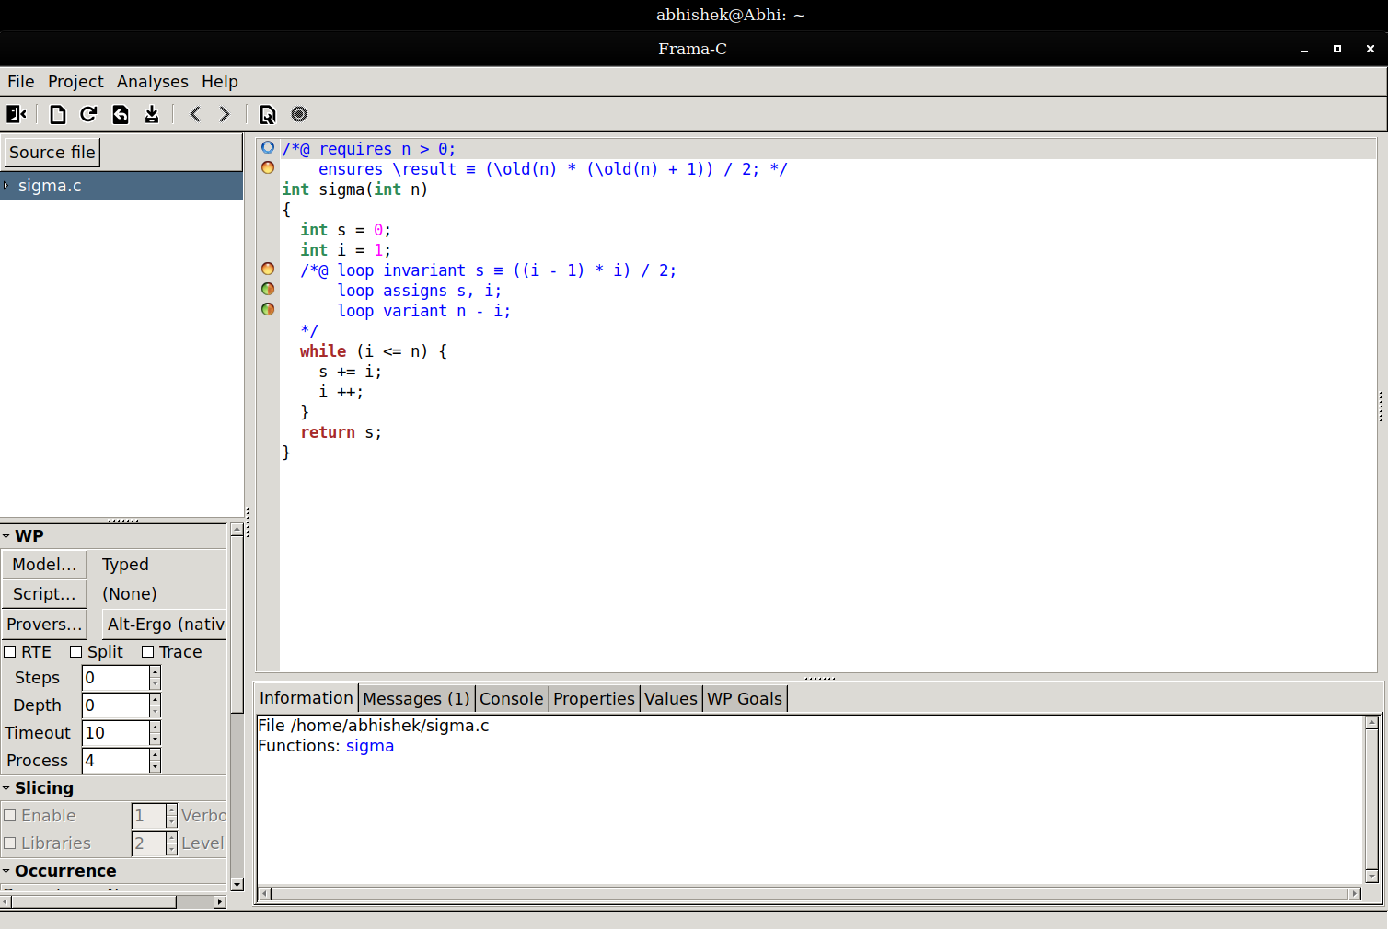

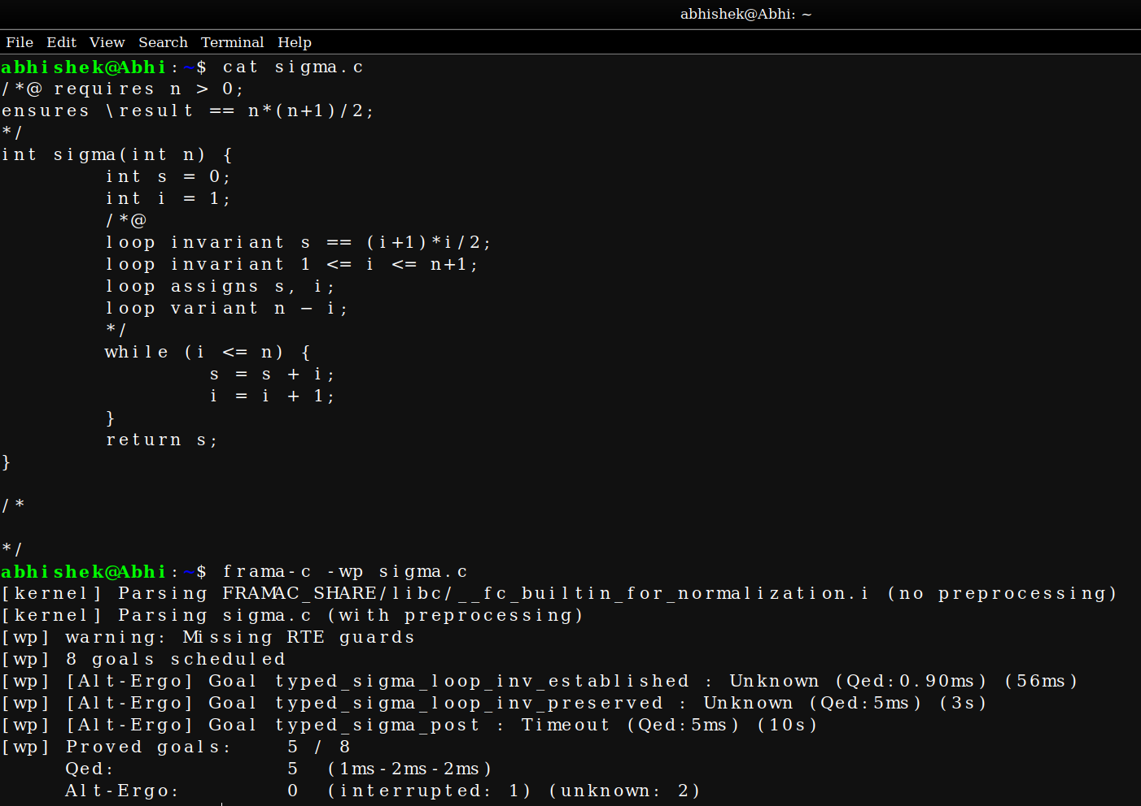
Here we have Replaced (i−1)*i/2 with i*(i+1)/2 in first loop invariant.

It results in the wrong sum result after each iteration since we are adding one number rather than decreasing it.

So this specification doesnt prove and frama-c results in the error.

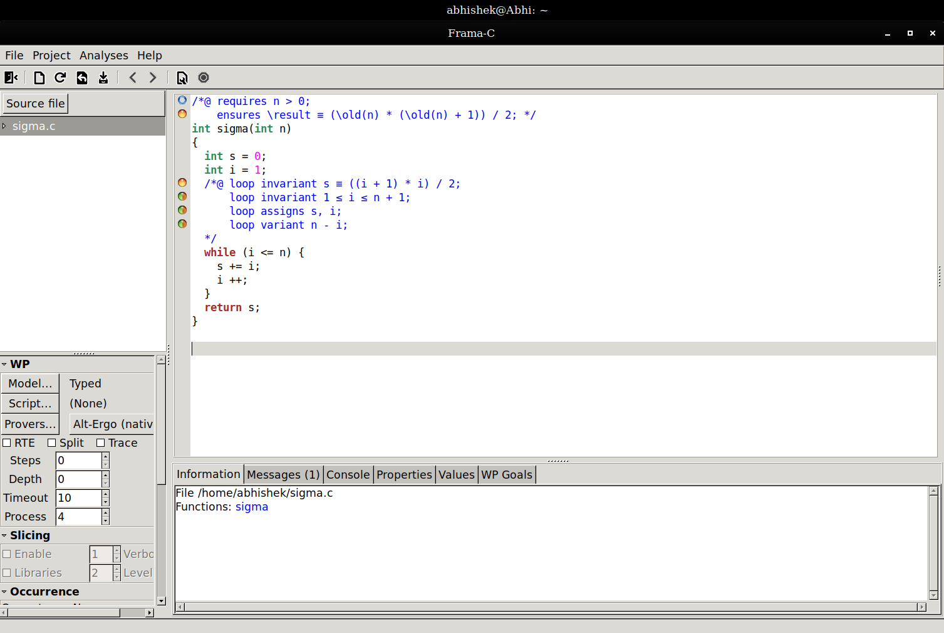

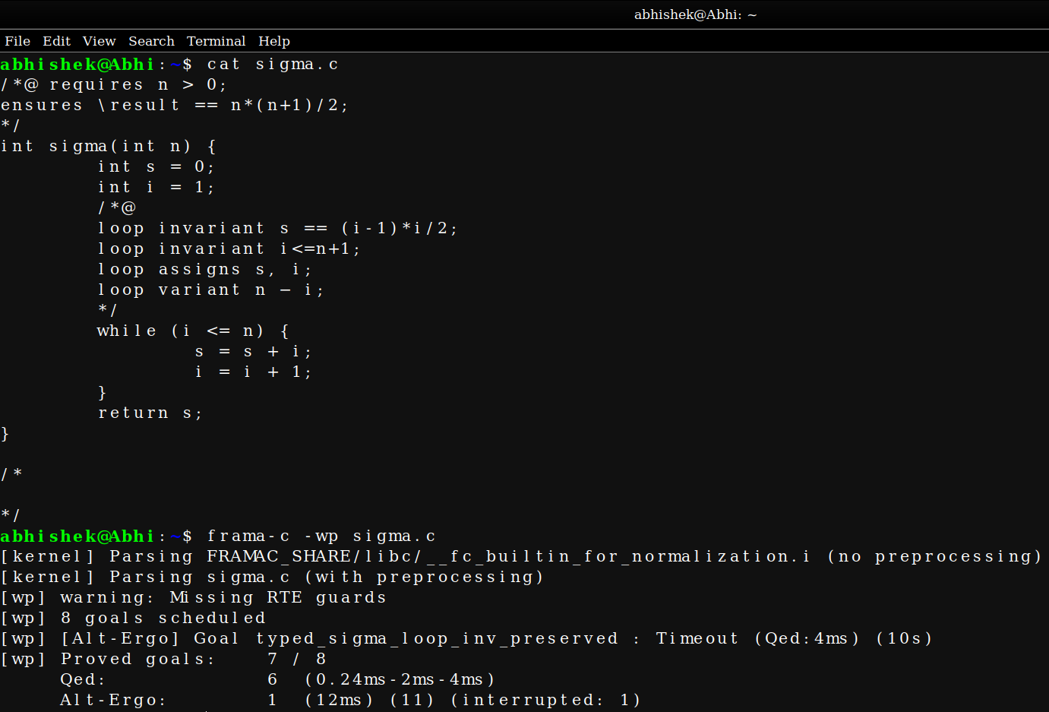

Here we have Replaced loop invariant 1 <= i <= n+1; with loop invariant i <= n+1;

Here it give the time out error since we didnt mention the limit in which it should start.

We have mentioned the end limit but not the starting limit.

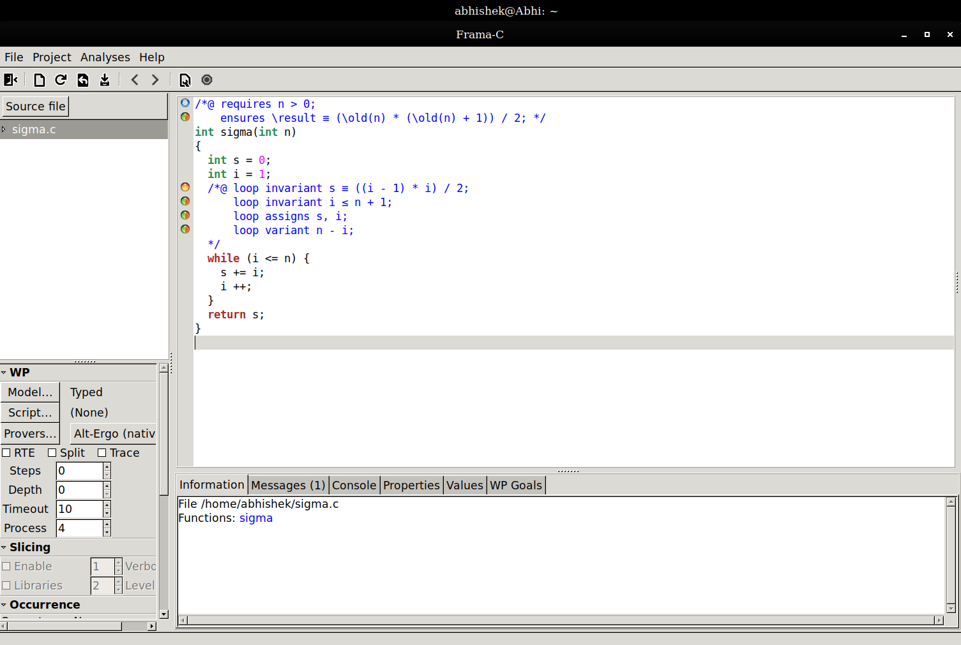

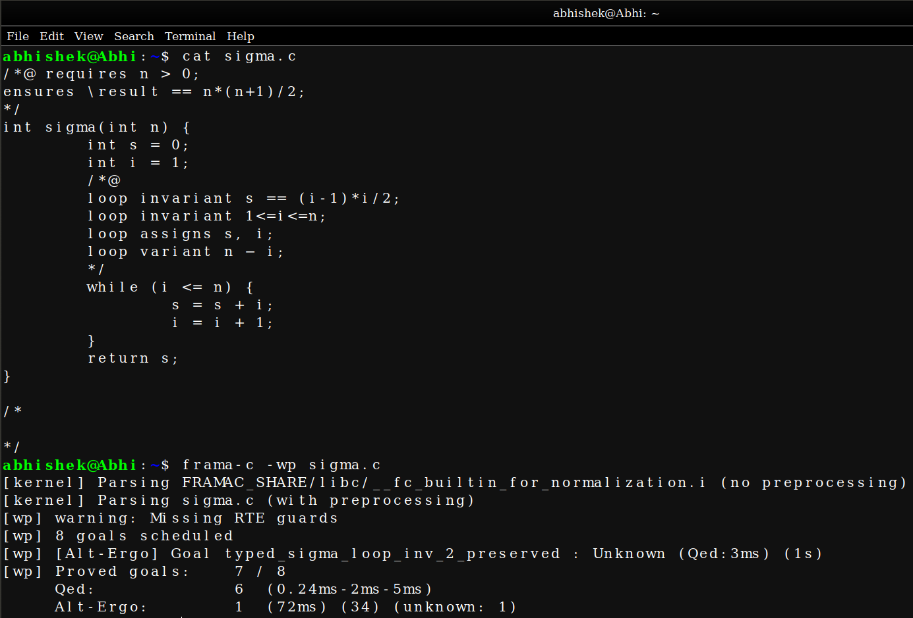

Here we have Replaced the loop invariant 1 <= i <= n+1; with loop invariant 1 <= i <= n;

Here the ‘i’ iterates till n+1 condition since the the loop terminates onely after reaching the specified condition.

The mentioned condiotion is one iteration less than the actual iteration takes place.

Hence the Frama-C fails to verify it and results in the error.

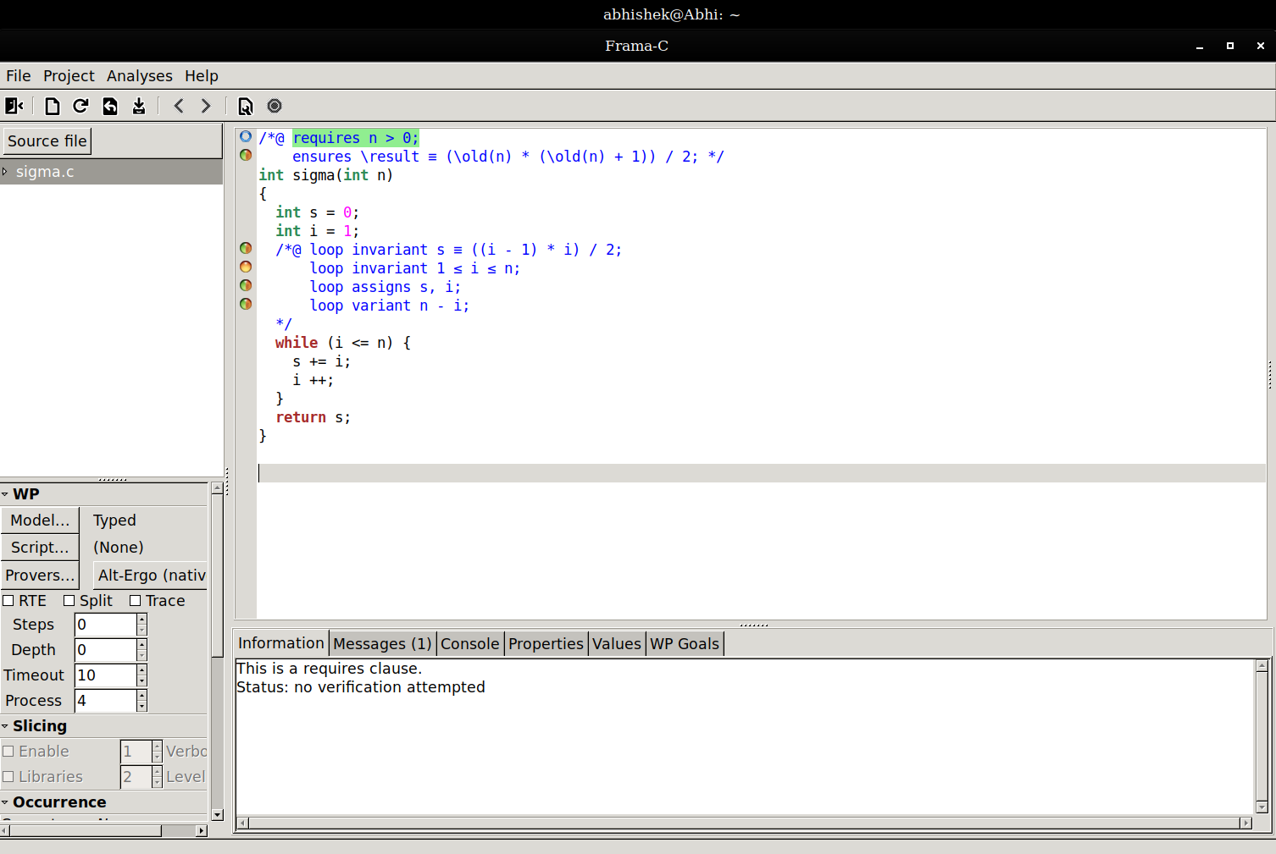
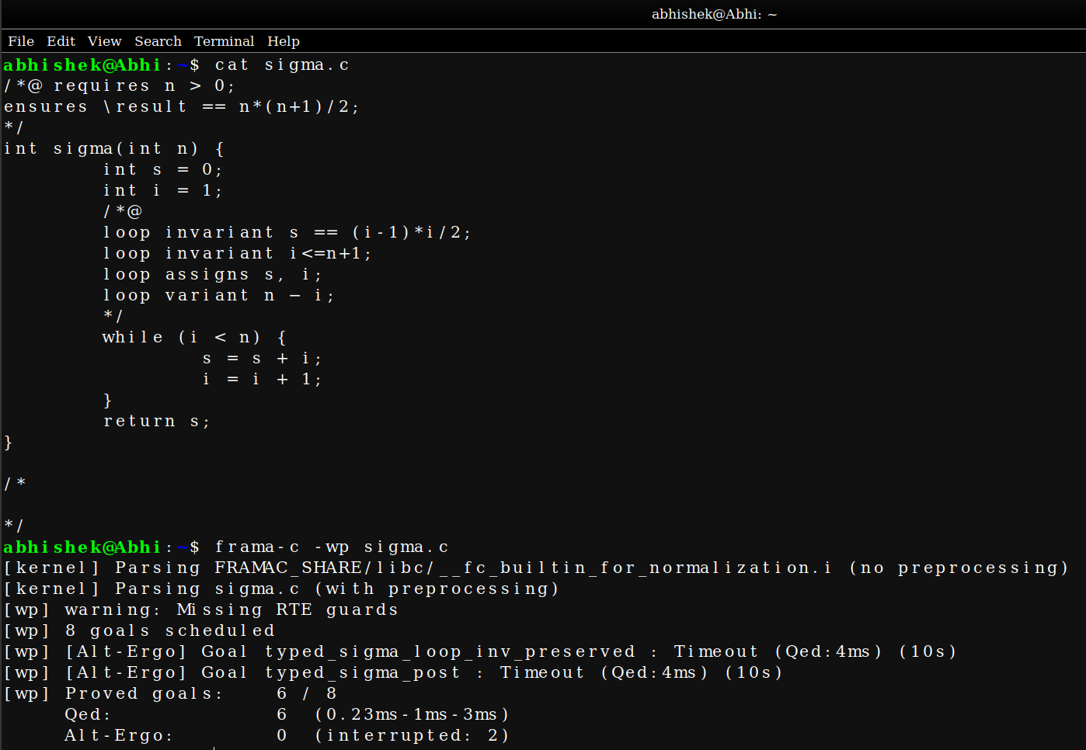

Here we have Replaced the loop invariant 1 <= i <= n+1; with loop invariant i <= n+1;

Here it give the time out error since we didnt mention the limit in which it should start.

We have mentioned the end limit but not the starting limit.

In addition to that we have also replaced the while (i <= n) with while (i < n) .

It is 1 iteration less than the required n number of iterations.

Here the iteration starts with 1 and ends with n to calculate the sum of first n numbers.

Since we have started from 1 we have to go till the nth (ie) end condition to get the sum till n’th number.

Here since its reduced with 1 iteration the n’th value is not added to the sum and the it fails to prove the requires specification.

Thus the Frama-C throws an error.

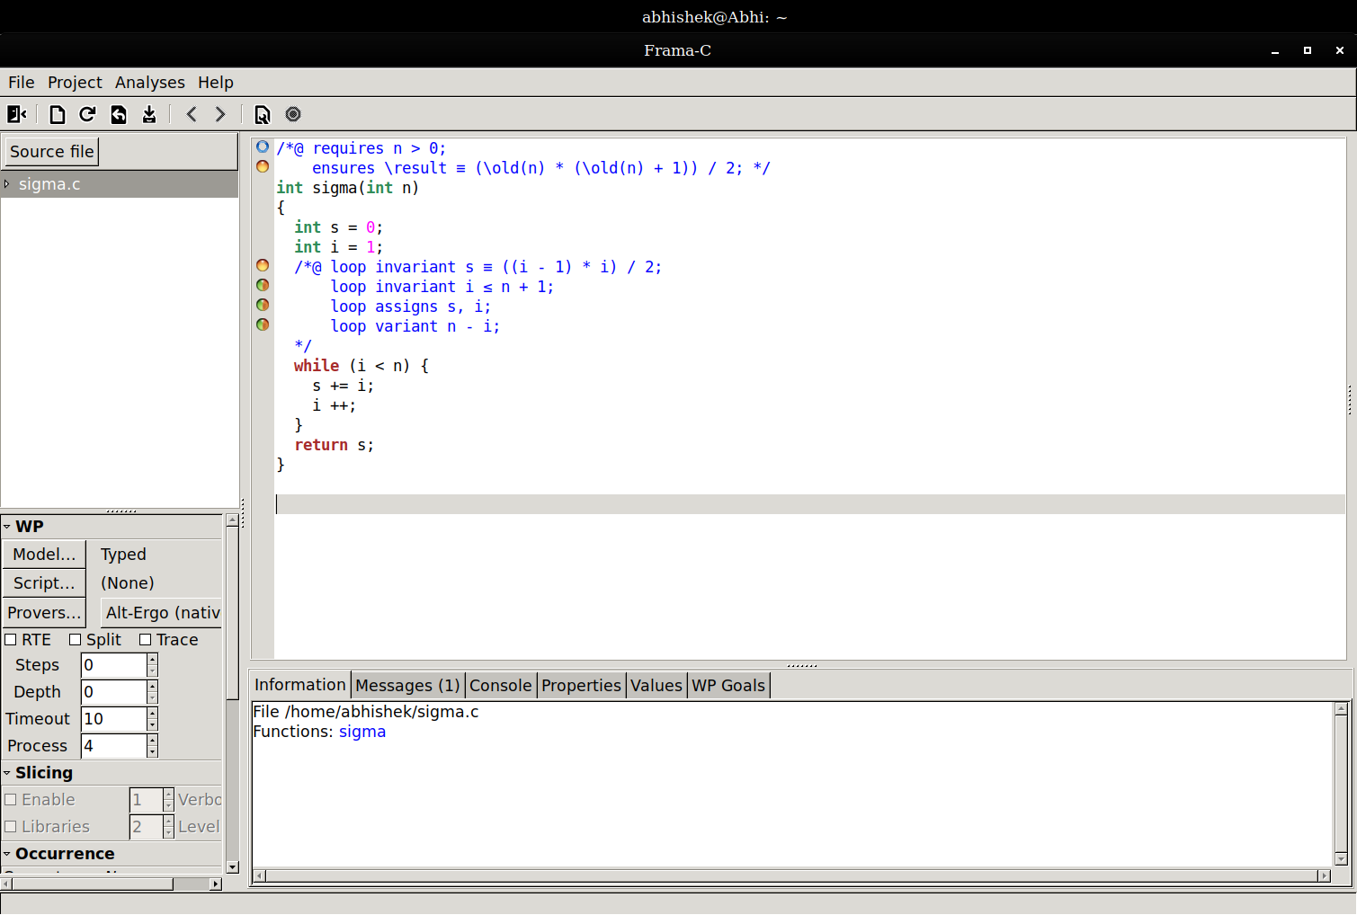

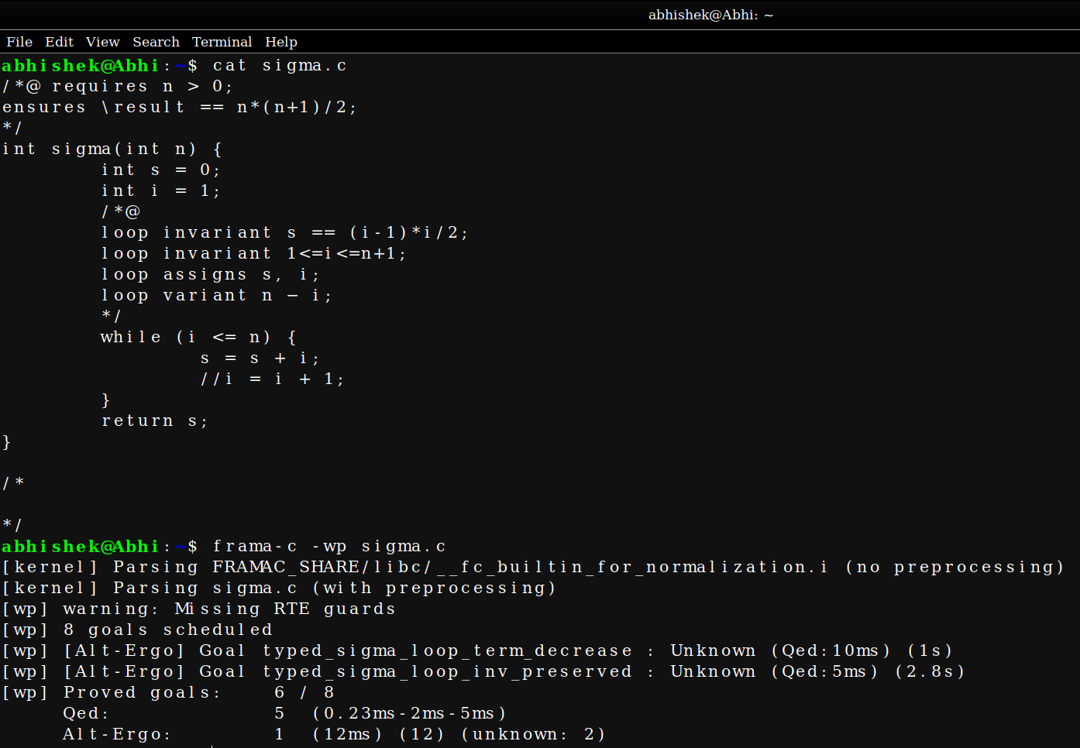

Here we have Removed the statement i = i + 1;

This is the most important statement in the while loop because this statement only decides whether the loop will or not.

If we remove the statement it loop continues iterating infinite number of times which doesnt satisfy our termination conditon which we gave as a specification in the loop invariant.

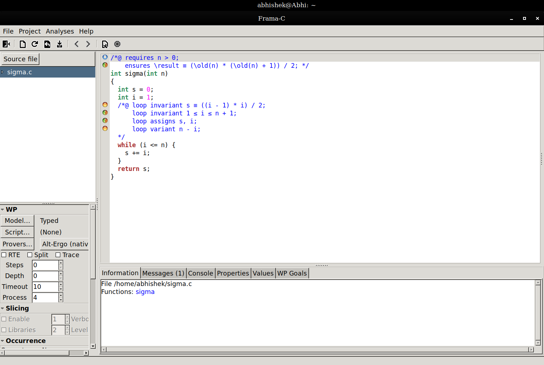
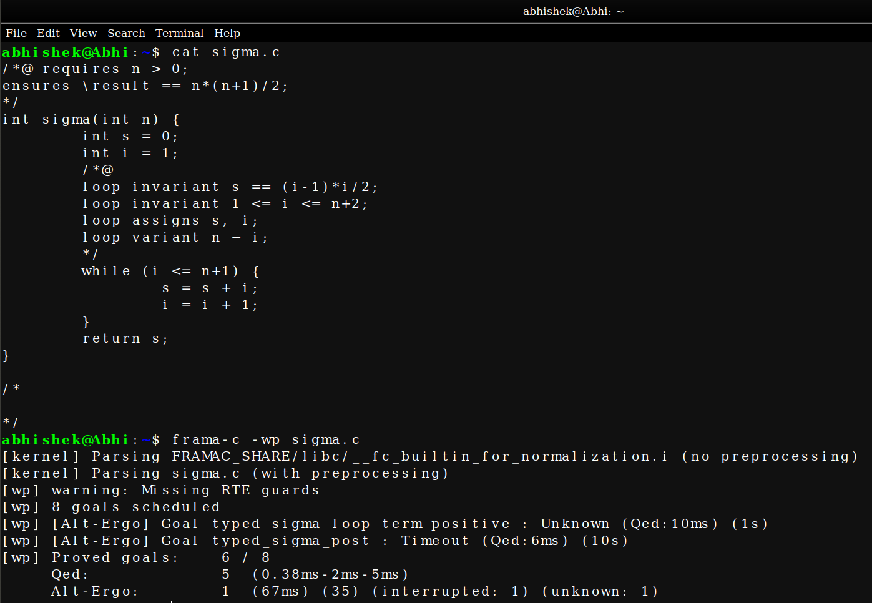

Here we have Replaced loop invariant 1 <= i <= n+1; with loop invariant 1 <= i <= n+2;

Since we have replaced the iteration limit to n+2 we have to increase the iteration conditon in while loop to satisfy this condition.

Initially while condition will be while (i <= n).

Here we have to increase one more to satisfy the 1 <= i <= n+2; condition.

Here though we change the logic according to our specification the final sum which we get will be wrong.

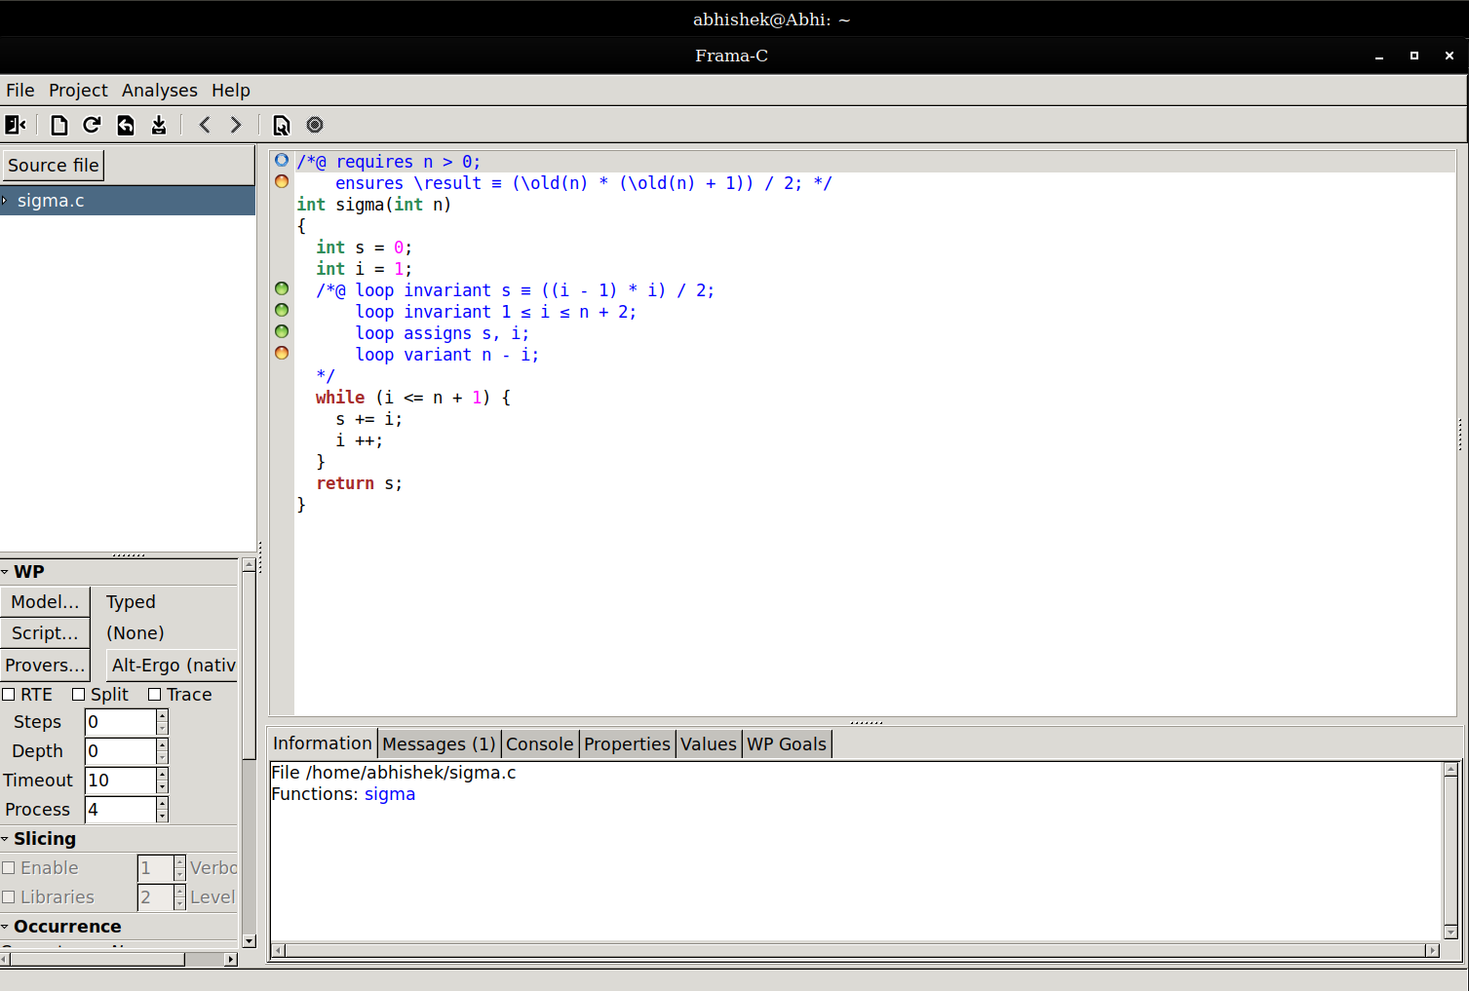

We have done the previous problem in reverse order.

Since we have given from reverse order we give the while condition according to that and we have also modified the specification part.

We have mentioned n>= i >= 0 since we start from ‘n’ and in ‘1’.

We have also modified the loop invariant specification accordingly which satisfies the required sum output after each iteration.

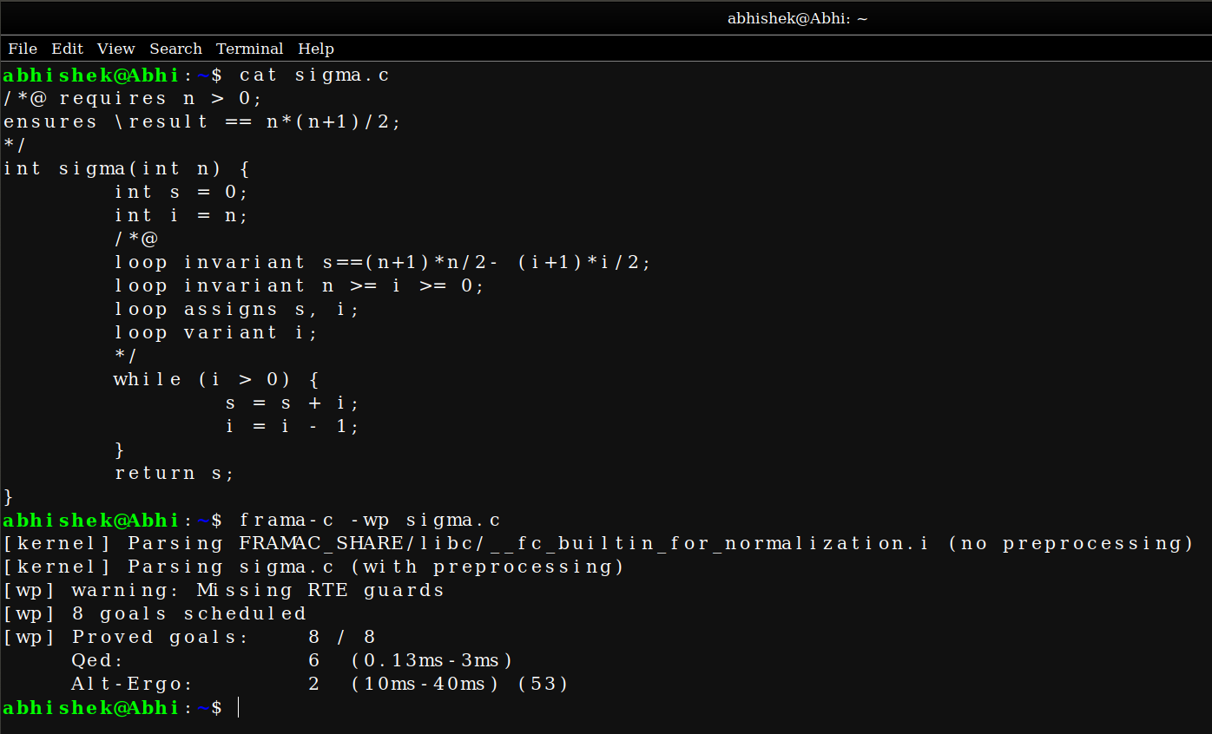

Here we have written a program to compute 1^2 + 2^2 + .... + n^2 and proved it using Frama-C.

Here the series condition is n(n+1)(2n+1)/6 for Square series and we have modified the previous specification according to the series condition.

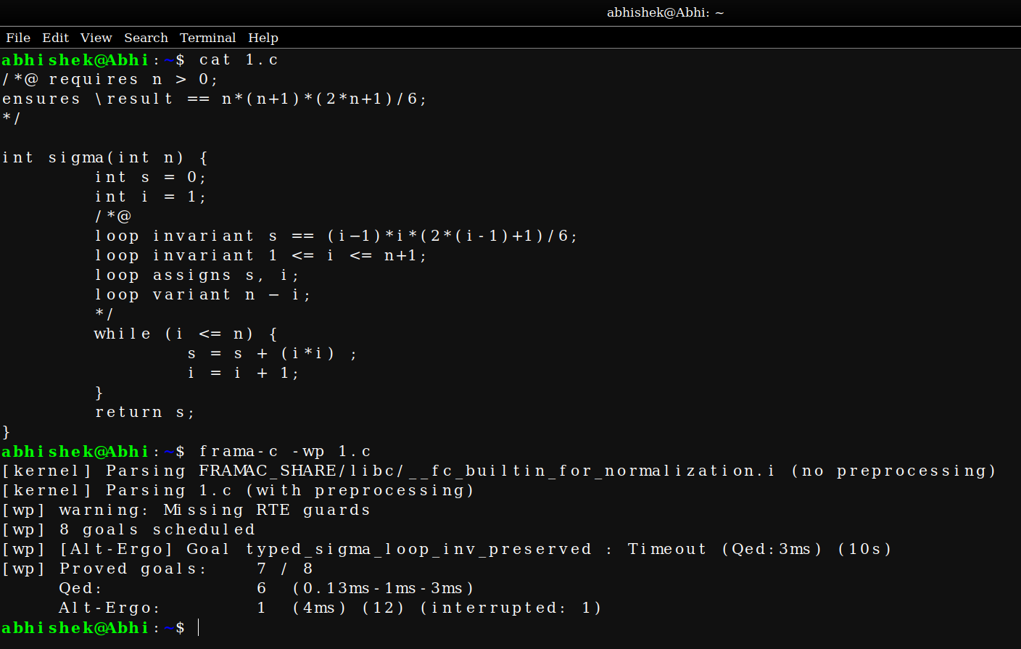

THANKYOU !!!

